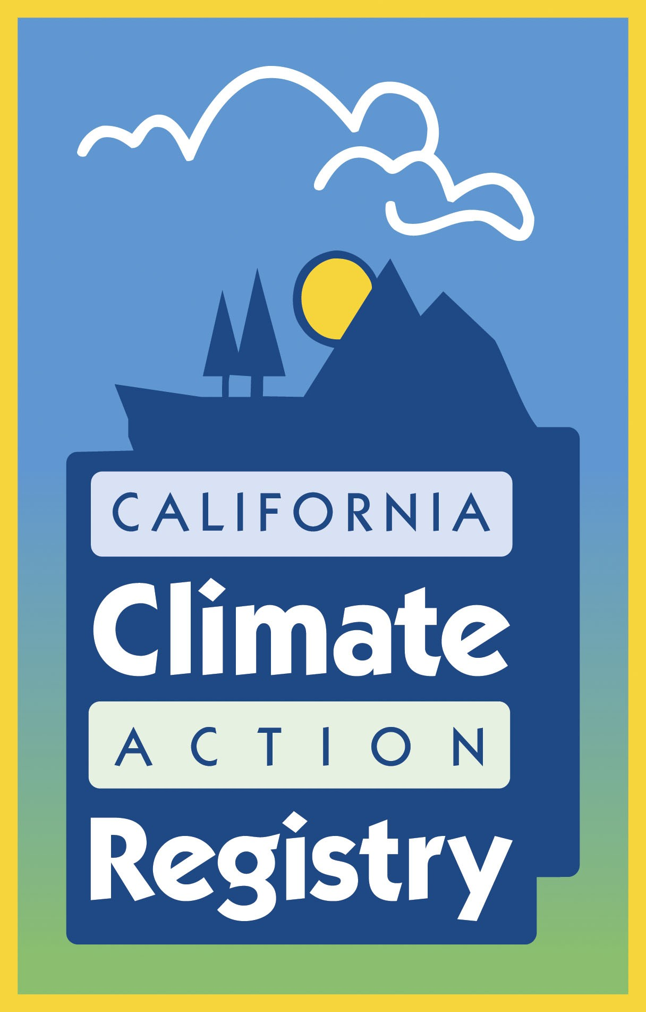

Form COI Renewal:
Notification of Verification Activities
and
Request for Evaluation of Potential for Conflict of Interest
Between Verifier and California Registry Member

This worksheet should be used for proposed verifications when your firm has verified the member’s emissions inventory in the previous calendar year. Please refer to COI forms that your firm submitted for this member in previous years so that you have adequate background information to prepare this form. If your firm did NOT verify the member’s emissions inventory last year, use Form COI-AB instead of this form.

This is a protected Word document; use the tab to move from field to field or use your cursor to select a specific field. If you need to add more space to any section of the form, please unprotect the document to make the edits. You must convert this document to pdf format before submitting it to the California Registry.

Please respond fully and in detail to all of the following questions. If you have no prior relationship with your potential client, you may answer “No” or “Does Not Apply” to many of the following questions, but you should answer every question. If you are a lead verifier using subcontractors to complete the proposed verification, you must also provide information for all subcontractors to be used.

All confidential information should be so designated.

All State- and California Registry-approved verifiers must complete this form prior to finalizing contract negotiations for verification services with a California Registry member. Upon review, and finding that all necessary information is complete, the Registry will consider the following information and provide a determination of the potential for a COI within no later than 30 days from the date it is received.

Email this completed form (saved as a pdf file) to COI@climateregistry.org a minimum of TEN (10) business days prior to beginning verification activities.

Date:
California Registry Member Company:
First Year of Reported Emissions: | 2009  2008  2007  2006  other ________
Reporting Protocol(s) Used: | General Reporting Protocol (version 3.1, February 2009)  Power / Utility Reporting Protocol (April 2005)  Forest Sector Protocol (September 2007)  Cement Sector Protocol (December 2005)  Other (please specify):
California Registry Member Contact:
Title:
Telephone:
Email:
Mailing address:
Verifier Company:
Lead Verifier:
Title:
Telephone:
Email:
Mailing address:
Will an ANSI witness assessment be completed in conjunction with the verification activities? |  | Yes No
To the best of my knowledge, I __________________________________ (printed name) attest that the information provided in support of this evaluation is true and complete and that I have complied with the California Registry's current Policy & Process for Determining the Potential for Conflict of Interest between California Registry Members and Verifiers.

___________ _________________________________________________________
(Authorized signature)

Based on the information provided in the following pages, or if nothing has changed since the previous year’s verification, we believe that our risk of conflict of interest is:
High Medium Low
Has anything changed since the last verification with regard to the conflict of interest between you and the member?  If YES, please proceed to fill out the rest of this form.  If NO, and there have not been any substantial changes from the initial COI, please only complete Part A and #5-7 of Part B. |  | Yes No
Part A: Schedule of Verification Activities
1) Total Number of Facilities:
2) Number of Facilities expected to be visited for verification:
Please attach a list of sites to be visited with the facility address, and anticipated date of visits.
3) Number of Facilities visited in last verification, if any:
4) Please provide estimated date for each activity:
a) First verification meeting:
b) Final verification meeting:
c) Completion of verification activities:
5) Provide a brief description of planned verification activities specific to this reporter. Your response should provide a general overview of the scope and breadth of verification activities. This may include, but should not be limited to, plans to interview which
staff, types of records that will be reviewed, emissions that will be reviewed, etc.:

Part B: Evaluation of Potential for Conflict of Interest
1) Which reporting years have you verified for the Registry member and when did the verification activities occur?
Calendar Year(s) emissions verified:
Dates of service (month/date to month/date):
 |  |  | YES | NO
2) Have any additional services been provided to the member since the most recent verification activities (listed above)
If yes, please complete the table below detailing these services
Non-GHG Services | Dates of Service (mo/year-mo/year) | Description of Services (including any links to GHG accounting and/or climate change, if applicable) | Value of Services | % of Your Total Revenue
 |  |  | $
 |  |  | $
 |  |  | $
 |  |  | $
 |  |  | $

 |  |  | YES | NO
3) Are the services outlined in question 2 (if any) different than the types of services previously provided?
If yes, please highlight and explain the differences:
 |  |  | YES | NO
4) Have there been any other significant changes in the nature of the relationship between your company and the member since the previous year verification services were completed? Examples of this may include, but are not limited to new subcontracts between your company and the member, new formal affiliations, joint ventures, partnerships, and casual or familial relationships.
If yes, please describe:
Also, please illustrate by attaching revised organizational charts.
5) List each staff member to be assigned to the proposed verification, identifying any previous work these individuals have conducted for member including while in the employment of other organizations. If staff members that worked on the previous year’s verification will be working on the proposed verification, be sure to highlight any changes in their relationships with the member organization. Please copy the table as many times as necessary to identify all staff who will be assigned to the verification.

Name:
Telephone number:
Email address:
Business location (city, state):
Previous work for Member (description of services):
Date of Services
(month/year to month/year):
Employer at time of service:

Name:
Telephone number:
Email address:
Business location (city, state):
Previous work for Member (description of services):
Date of Services
(month/year to month/year):
Employer at time of service:

 |  |  | YES | NO
6) Have there been any changes in the organizational structure of either your organization or the member’s organization?
If yes, please highlight and explain the differences:
7) Please complete the information below regarding verification services for the Registry member.
Member Reporting Boundary: |  |  | California  United States
Expected Scope of Proposed Registry Verification Services: |  |  | Calendar Year Emissions
Expected Value of Proposed Registry Verification Services: |  |  | $
Prior Registry Verification Services for Member in Reporting Boundary  (calendar year) | Value of Prior Verification Services for Member |  | % of Your Total Revenue | Emissions Year(s) Verified
2007 | $
2008 | $
2009 | $
Value of Anticipated Services for Member in Reporting Boundary (excluding potential Registry Verification Services) |  |  |  | Types of Services  (excluding Registry verification)
2010 |  | $ | FORMTEXT
2011 |  | $
2012 |  | $

